**[ Page #1: Home Page ]**

[ Layout ]

Visakan Jayakumar | UX Portfolio

[ curiosity ] + [ empathy ] = [ the optimal UX ]



[ Menu ]

UX Work

About

Resume

|  |  |
| --- | --- |
| Facebook: UX Research Internship | Feeding Pump UI: UX Research & Usability |
| Menlo Innovations: Ethnography | Self-Injection Device: UX Research & Usability |
| Court App: UX Design | Airbnb Design Jam: UX Design |

**[ Page #2: Feeding Pump UI ]**

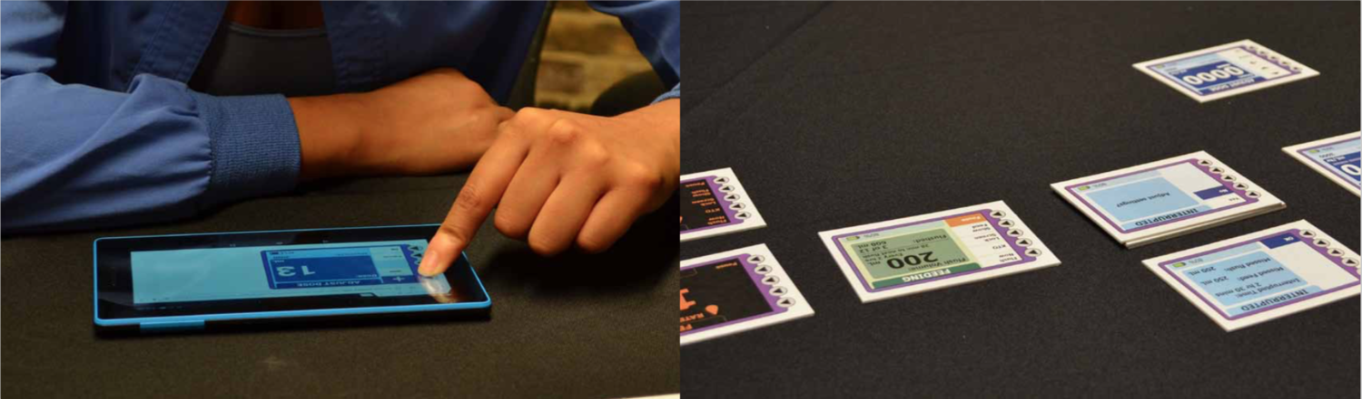

***My Responsibilities*** *Study Design, Protocol Development, UI Development, Participant Recruitment, Moderation, Note-taking, Data Analysis, Final Report & Presentation Writing*

***My Role*** *User Researcher, Usability Tester*

***Methods*** *User Interviews, Usability Testing, Card Sorting*

***Tools*** *InDesign, Photoshop, Illustrator, Axure*

**ABOUT**

The client wanted to revamp and modernize the outdated UI on their existing enteral feeding pump's display and needed to down-select options for different features and refine the new Information Architecture.

The 3 features being tested with users on the new touchscreen UI were:

1. Programming different feeding settings
2. Navigating to and viewing the flush (water) settings
3. Switching the display into Night Display

RESEARCH GOALS

1. *Identify the extent to which each design concept addressed user needs*
2. *Identify use errors associated with each concept*
3. *Identify users' preferences, perceived benefits, and concerns for each concept*

THE CHALLENGE

*Select****one****concept for each of the 3 tested features to move forward with.*

## ****METHODOLOGY****

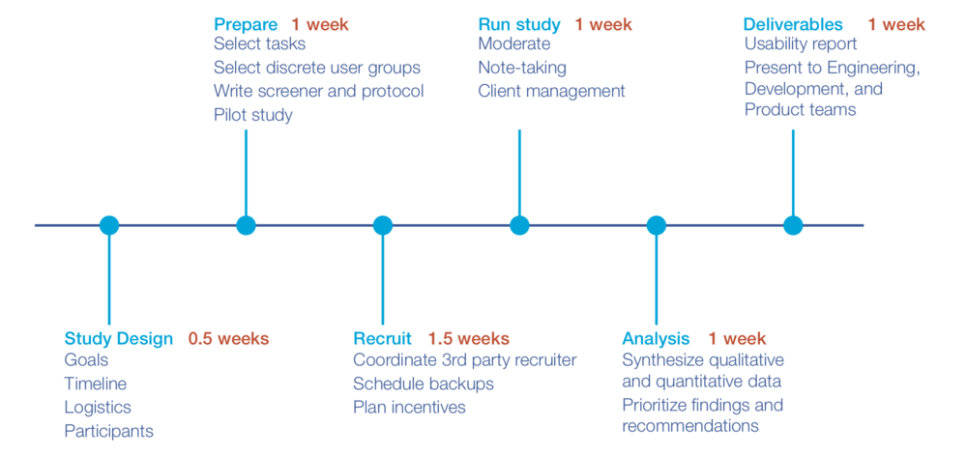

## Participant Recruitment

Target users were:

* Acute Care nurses
* Extended Care nurses

I developed a participant recruitment screener for our 3rd party recruiting partner to find **12 nurses** who:

* Ranged in nursing experience
* Worked in either Acute Care (e.g. ICU) or Extended Care (e.g. Care Home)
* Ranged in experience using an enteral feeding pump
* Ranged in frequency using the feeding pump during the week

## Interviews

Interview Structure:

Interviews were conducted as 1-on-1 sessions at a research facility and lasted 60 minutes.

1. **Intro:** welcomed participant, provided session overview
2. **Background:** asked questions regarding feeding pump experience
3. **Device Introduction:** introduced feeding pump whose UI was being updated
4. **Concept Evaluation:** presented different concepts for each feature, observed usability, ease of use, and preferences
5. **Wrap-Up:** thanked and compensated participant

## Stimuli

**Feature 1 UI Concepts:** Programming different feeding settings

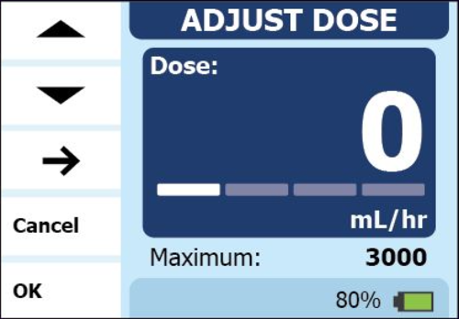

**D1-A:** adjust each digit by moving underline (1 zero shown)

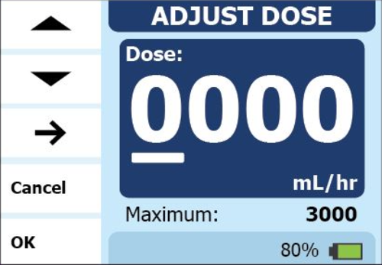

**D1-B:** adjust each digit with moving underline (3 zeroes shown)

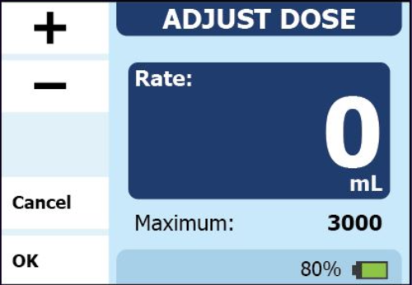

**D2-A:** press and hold to increment by 1, then by 5, then by 10  
**D2-B:** press and hold to increment by 1 (constant speed)  
**D2-C:** press and hold to increment by 1 (faster speed)  
**D2-D:** press and hold to increment by 10, tap to increment by 1

*Questions:*

1. *How many zeroes do users want to see when starting to program?*
2. *Do users want to move between digit spots to adjust specific digits (D1) or adjust the entire number (D2)?*
3. *When pressing and holding (D2) the + or - buttons, how fast should the number increment?*

**Feature 2 UI Concepts:** Navigating to and viewing flush (water) settings

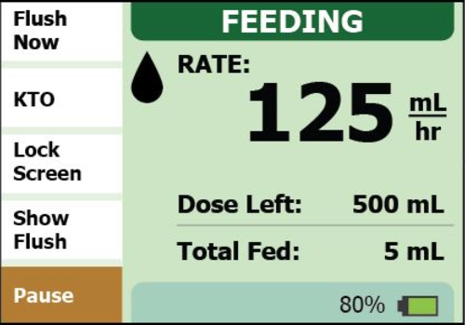

**F1:**Show Flush button on Feeding screen

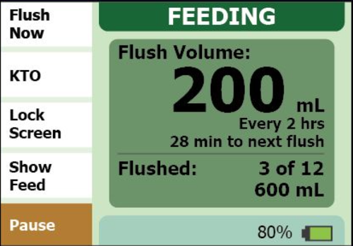

**F1 (cont.):**flush button and 5 sec flush information pop-up

*Questions:*

1. *Do users notice the difference between the Feeding screen and the Flush pop-up?*
2. *How long should the pop-up persist on the screen?*

**Feature 3 UI Concepts:** Switching display into Night Display

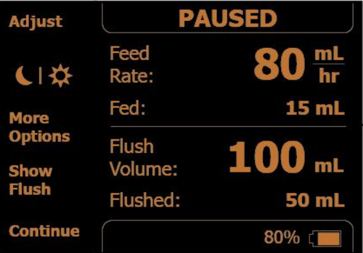

**N1:** Night Display button on Pause screen, reduced menu on Feeding screen

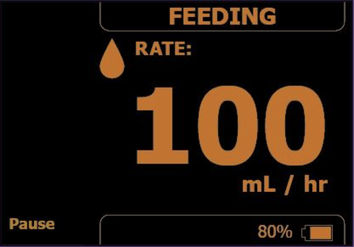

**N1 (cont.):** reduced menu on Feeding screen

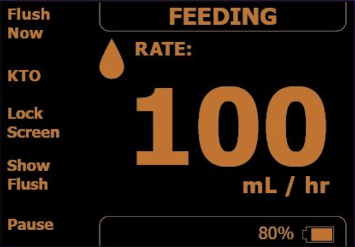

**N2:** physical Night Display button on pump's frame, full menu on Feeding screen

*Questions:*

1. *Do users want to toggle Night Display on the Feeding screen or the Pause screen?*
2. *Do users need to have a full menu on the Feeding screen when in Night Display?*
3. *Do users prefer the Night Display button to be a UI button or a physical button on the pump?*

## ****FINDINGS****

**Feature 1: Programming different feeding settings**

**WINNER**  
D1-A

10/12 participants preferred D1-A (moving underline with 1 zero shown) over the other concepts. They felt D1-A required much less time and was easier to enter the desire values with.

**Feature 2: Navigating to and viewing flush (water) settings**

**WINNER**  
F1

Almost all participants liked having the flush info accessible via pop-up. They liked that the pop-up disappeared on its own. A few wished the pop-up persisted slightly longer for adequate reading time and a few were unsure what the bottom-most volume ("600 mL") represented and requested a clear label.

**Feature 3: Switching display into Night Display**

**WINNER**  
N2

All participants preferred the N2 concept (separate, physical button) and liked having all button labels accessible and shown on the Feeding screen.

Participants felt important info was sufficient and easy to read, even from a distance or when the testing room lights were dimmed. Several felt it was not intuitive to find the button in the Pause screen (N1). Participants wished Night Display would stay On until they pressed the button to turn it Off.

## ****RECOMMENDATIONS****

Using the qualitative and performance data from the user study, the following concept recommendations were made for each of the 4 tested features:

**Feature 1: Programming different feeding settings**  
Recommendation: Implement D1-A with elements of D1-B

* ensure underline is easy to see (e.g. improve contrast)
* utilize +/- symbols for incrementation (not up/down arrows)
* improve Next Digit button location so button is readily apparent

**Feature 2: Navigating to flush settings**  
Recommendation: Implement F1

* ensure bottom-most value clearly refers to volume delivered (e.g. "Total Flushed")
* consider increasing pop-up persistence time
* consider adding Show Flush button on Pause screen

**Feature 3: Switching display into Night Display**  
Recommendation: Implement a solution that captures convenience of N2 (turning on with single button press) without requiring a physical button. The physical button would derogate the visual aesthetic of the device and may increase confusion with other physical buttons.

* explore ways to incorporate Night Display button on Feeding screen
* consider having Night Display stay On until user presses button to turn Off
* if physical button: ensure there is no confusion with the Power button

## ****Redo****

* Conduct a Heuristic Evaluation first: down-select from 5 Programming concepts
* Consider remote sessions for Usability (cheaper, wider geographic reach for international goals)
* Utilize more realistic pump screen proxy
* Conduct 2nd round of Usability for statistical power: 15+/user group
* 5-sec Usability test

**[ Page #3: Menlo Innovations ]**

# Menlo Innovations | Contextual Inquiry

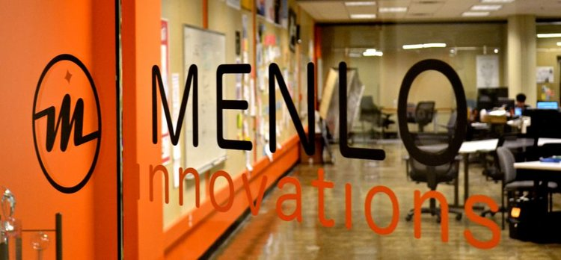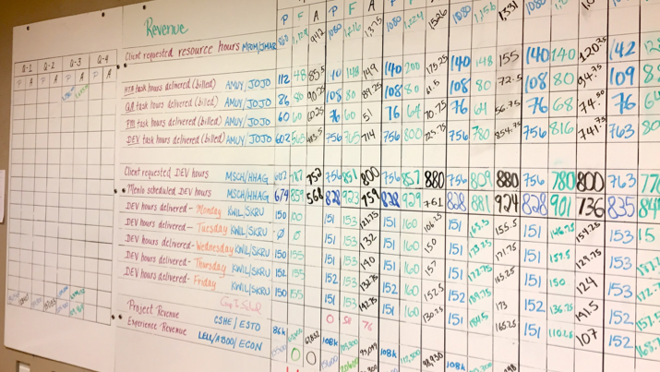

***My Role*** *Project Manager, UX Researcher, Data Analyst*

***Methods*** *Ethnographic Interviews, Contextual Inquiry, Affinity Diagramming*

***My Responsibilities*** *Protocol Development, Study Moderation, Note-taking, Data Analysis, Final Presentation and Report Writing*

## ****ABOUT****

As part of the SI 501: Contextual Inquiry & Consulting course, our graduate student team conducted a contextual inquiry for Menlo Innovations, a software and management consultancy. We completed 1:1 interviews, affinity walls, and data analysis to meet the following objectives:

* understand how employees used a physical financial metrics board
* inform recommendations for an optimized financial metrics board

Menlo Innovations asked us to optimize the way financial metrics are communicated and presented to employees to maximize employee engagement and possibly improve employee productive and work.

## ****BACKGROUND****

Menlo Innovations utilizes Open Book Management and **currently displays financial metrics on a whiteboard (called "Front Office Open Book Board" or FOOBB)** in an open meeting room. With OBM, management hopes employees will become more engaged in their work and adopt efficient, economic-based decisions when completing work. Menlo Innovations held weekly, company-wide meetings to discuss the financial metrics together. While employees grasp the definitions of some line items on the boards, few are able to connect associated metrics to form a holistic understanding of the company’s overall financial health. As a result, employees may not be performing as effectively as they could be.

## 

## ****THE PROBLEM****

Upper management felt that the FOOBB (financial metrics) board could be improved and optimized for employees. Employees may have been having difficulty interpreting financials on the board due to the way it presents information or more personal challenges specific to the employees.

**Our goal was to understand the context of the board's use, uncover any difficulties employees were having in their interactions with the board, and highlight areas for improving the way Open Book Management is implemented at Menlo.**

## ****METHODOLOGY****

1. Immersion | 2. Participants | 3. Interviews | 4. Analysis | 5. Findings | 6. Recommendations

## 1. Immersion

We sat down with Menlo Innovations for a deep dive into its organization structure and its application of Open Book Management. We clearly defined the project’s scope and identified responsibilities for both the research and client teams. After our initial client meeting, we sat in on a weekly financial metrics meeting to gauge the general dynamic as well as employee understanding, morale, and engagement.

## 2. Participants

As outlined by the client, the intended users of the financial metrics board were upper management and the following roles:

* Project Managers
* Software Developers
* Quality Advocates
* High-Tech Anthropologist

## 3. Interviews

Interviews were conducted with end users (employees) in a meeting space at Menlo Innovations. Interviews were conducted as **one-on-one, 60- to 90-minute in-depth discussions**.

Our goal for conducting the interviews was to answer these overarching questions:

* How do employees understand the financial metrics board and Menlo’s overall financial status?
* How can the weekly financial meetings be optimized?
* How does their understanding of the financial metrics impact their work?
* Are there gaps between management's expectations and how employees behave?
* What metrics do they find valuable that should be better understood by other employees?

**Interview Structure**

**(a) Intro & Background**

* welcomed participant
* provided session overview
* discussed financial understanding
* discussed initial impressions of the metrics board

***(b) Weekly Meetings***

* participant gave detailed account of the last meeting

***(c) Financial Understanding***

* participant discussed understanding of the financial big picture
* participant asked to explain associations between different metrics

***(d) Wrap-up***

* asked follow-up questions
* thanked the participant

## 4. Analysis

**INTERPRETATION SESSIONS**  
After each interview, the team sat down and listened to the interview recording, highlighting notable comments and findings.

**AFFINITY DIAGRAMMING**  
400+ key comments and quotes from interviews were attached to sticky notes:

Notes were clustered with 5-6 other relevant comments/quotes. Clusters were then grouped (and so on) to form a **hierarchy of granular patterns moving upwards to high-level themes.**

Weconstructed the following themes:

* Presentation of Data
* Employee's Individual Differences
* Lack of Understanding & Direction
* Constraints
* FOOBB Methods
* Business Methods

## 5. Findings

Analysis gave way to the following findings:

**Positives**

* employees understand FOOBB much better when coworkers share the "why" behind the metrics
* employees use certain metrics like Billable Hours as markers for Menlo's financial health
* Project Managers often have an easier time understanding metrics and the bigger picture than other employees
* a majority want to understand FOOBB better
* some employees use FOOBB to inform their personal finances
* employees find pairing with a coworker to be valuable

**Issues**  
We uncovered high-level issues with FOOBB and Menlo's implementation of Open Book Management:

- connections are hard to make on the board- info on the board is not easily digestible- the board is not conducive to visual learning

a) PRESENTATION OF DATA

b) ACCOUNTING FOR EMPLOYEE DIVERSITY

- the board does not account for individual preferences- employees without management experience struggle- those less familiar with the flow of business were more pessimistic about Menlo's financial health

c) UNCLEAR EXPECTATIONS

- employees are expected to invest emotionally  
- management expects employees to spend extra time using metrics to improve the business- employees are busy with client work

d) VALUE OF WEEKLY MEETINGS

- employees wished less time was spent calculating- employees want to make proactive decisions- the story behind the metric is imperative to teaching

e) INEFFICIENT QUARTER TRANSITIONS

- new quarters = new metrics to learn, wastes time- researching new metrics does not follow a process

## 6. Recommendations

We brainstormed and potential solutions that Menlo could use to improve the way employees interact with Open Book Management and the giant whiteboard.

To narrow our solutions, we evaluated them against the following qualities:

* political support among upper management
* political support among employees
* simplicity
* degree to which the problem is solved
* financial cost
* required effort
* technical feasibility

Prioritizing and down-selecting the solutions left the following as our top recommendations for the client:

**Train employees on Open Book Management**

* align the team on the value of OBM
* onboard newer employees and those who struggle with FOOBB
* pair a learner with a mentor to ensure constant learning and efficiency
* educate employees on the nature of business and consulting

**Make creating the "story" easy**

* consider creating 'mad-libs' to allow employees to plug-n-present the story
* devise tips for researching, analyzing, and presenting different metrics

**Clearly communicate expectations**

* spend time in the weekly meeting reinforcing employee expectations
* bridge the gap between expectations and reality
* discuss ways to work around the time required for billable work
* ensure employees do not feel guilty when spending time on FOOBB

**Visualize data to show connections**

* consider creating graphs connecting metrics to be updated weekly
* group related metrics adjacent or near each other to promote connections

**Implement a feedback system**

* encourage employees to provide feedback for a given financial decision
* ensure employees feel heard and prioritized within the business model

**Optimize meeting quality**

* use weekly meetings to analyze metrics and discuss proactive solutions
* spend less time number-crunching and more time thinking analytically
* consider deciding next week's meeting topic in this week's meeting
* use the end of quarters to devise research approaches for new metrics

## ****REFLECTION****

What did I learn?

* **Ethnography is not Usability:**  
  contextual inquiry should be much less directed than a typical usability session with a very flexible interview protocol
* **Interviews with stakeholders can be just as valuable:**  
  interviewing the CEO highlighted unmet expectations that had not been communicated to the team

What would I do differently?

* **Conduct interviews in the same environment as observation:**  
  keep participants thinking in-context so they provide relevant answers and recollect nuances they might otherwise forget
* **Brainstorm ways to increase employee buy-in:**  
  regardless of how great a product is, users must want to use it, so increasing buy-in and retention could have helped this system

**[ Page #4: Self-Injection Device ]**

# Self-Injection Device | Qualitative Research & Usability

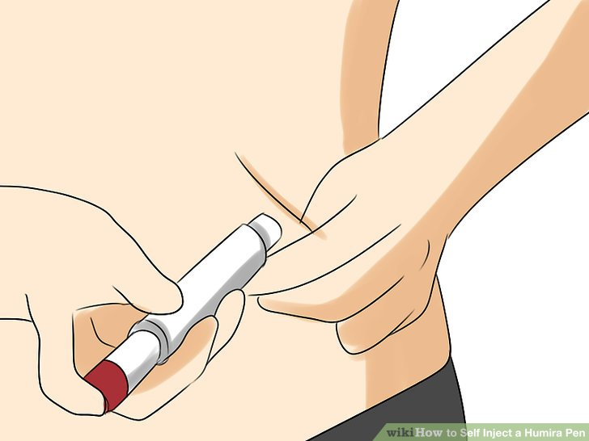

***My Role*** *User Researcher, Usability Tester  
Client: Pharma-C*, a pharmaceutical company*

***My Responsibilities*** *Study Design, Protocol Development, Participant Recruitment, Moderation, Note-taking, Data Analysis, Final Report Writing*

***Methods*** *User Interviews, Usability testing, Simulated Use, Contextual Inquiry, Cognitive Walkthrough*

***Tools*** *InDesign*

* Due to the confidentiality of this project, this research summary is adapted with false company names, alternative generic devices, and omits proprietary details

## ****ABOUT****

The client, Pharma-C, had already released its drug to the market but it was only available for use with a syringe and vial. The client wanted to select the ideal self-injection device to make treatment easier for the target patients. To do so, the client needed to understand how patients were currently using their syringes and investigate how potential users might feel about the 3 off-the-shelf devices being considered.

### RESEARCH GOALS

1. Understand the self-administration landscape
2. Explore the benefits and drawbacks of the 3 self-injection devices through metrics and qualitative data

### THE CHALLENGE

Select a single device that best suits the needs of potential users, is easy to use, and improves the self-administration experience

## ****METHODOLOGY****

## Participant Recruitment

The target users were identified to be:

* patients with autoimmune diseases
* healthcare professionals who worked with these patients

I created a participant recruitment screener (questionnaire) to be used by our 3rd party recruiting firm. We were looking for 25 patients who:

* ranged in age and gender
* experienced an autoimmune disease
* ranged in dexterity limitation (a side effect of the disease)
* ranged in experience level with self-administration (naïve, syringe/vial, pre-filled syringe, injector).

We scheduled 15 healthcare professionals, nurses and caregivers, who ranged in treatment experience and had varying experience levels with different self-administration methods.

The types of participants we recruited would be integral to answering these questions:

**How would the disease’s impact on lifestyle influence someone’s preferred method of administration?**

*e.g. "How would a rheumatoid arthritis patient’s dexterity limitations influence her administration method preference?"*

**How would disease symptoms affect device preference and use?**

*e.g. "How would a lupus patient’s feeling of lack of control impact his device preference for self-injecting?"*

To answer these questions later, the team would need to cross-reference research data and participant feedback with the participant’s device experience and dexterity limitation. To prepare, we mapped patient participants by these factors:

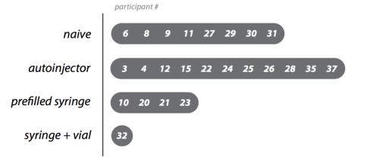

Dexterity Map

Injection Experience Map

## Interviews

Interview structure:

Interviews were conducted as 1-on-1 sessions at a research facility and lasted 60-75 minutes.

1. **Intro**: welcomed participant, provided session overview
2. **Background**: asked questions regarding medical conditions, self-administration experience, experience working with patients
3. **Current Context**: discussed impact of disease on life, current treatment methods
4. **Device Assessment**: participant received training and performed 2 injections with each device on a foam pad, looked for impressions, difficulties, and use errors
5. **Device Comparison**: asked participant to compare 3 devices and rank by preference
6. **Wrap-up**: thanked and compensated participant

## Stimuli

During the usability portion of the interview, participants were shown 3 devices: (these were not the actual devices used)

**Device #1**: push down on the top

**Device #2**: press the end button

**Device #3**: push against the skin

Aside from appearance, the devices differed in their methods of activation.

## ****FINDINGS****

## Disease Landscape

We asked participants to describe their experiences with their medical conditions. We explored each of the disease landscapes to understand how the conditions affected the participants’ everyday lives. (Diseases anonymized due to confidentiality).

AUTOIMMUNE DISEASE #1 & #2

* Pushes someone into early retirement
* Makes daily tasks like showering, cooking, and driving difficult
* Hobbies that involve dexterity like playing piano can be impossible

AUTOIMMUNE DISEASE #3

* Fatigue and ‘brain fog’ make it difficult to function in the morning
* Body stiffness make it painful to walk
* Finger locking can affect everyday tasks like cooking and dressing

AUTOIMMUNE DISEASE #4

* Person becomes lost mid-conversation
* Hands lock up and experience tremors

## Treatment Needs & Goals

We used participant experiences to write a visual story about the self-administration process.

Participants discussed their motivations and goals when self-administering the treatments for their conditions.  
They want to:

- Reduce injection time and steps  
- Experience less pain when injecting  
- Receive the complete dose

- Minimize disruption to their day  
- Maintain a regimented treatment routine  
- Feel confident and in control of the treatment

## Device Usability Assessment

An understanding of the current context would not be enough to choose 1 of the 3 devices to move forward with. Therefore, we had participants perform injections on a foam pad with each of the devices and discussed the following 4 factors:

1. APPEARANCE & SIZE
2. ERGONOMICS & EASE OF USE
3. MODE OF ACTUATION
4. FEEDBACK

shape, color, style visual treatmentgrip, comfort, handlingthoughts on activation, feeling of controlknowing the injection began and completed

## 

We analyzed the findings and compared the 3 devices using visual frequencies:

Size of the circles corresponds to the number of participants who mentioned characteristics related to these attributes.

We had participants rank the 3 devices:

We found that **participants with moderate to severe dexterity limitations were more likely to prefer Device #1** due to its easier activation:

**Injection-naïve (those without injection experience) were more likely to prefer Device #1**, mainly because it was easier to learn to use, appeared less intimidating, and was easier to activate:

## ****RECOMMENDATION****

We found that **Device #1 was the ideal choice** to move forward with.

* Healthcare professionals strongly preferred to train patients on it
* Patients with moderate-severe dexterity limitations strongly preferred it (and these represented the likely users)
* 100% of injections were successful with Device #1
* Participants felt more comfortable and in control when injecting with Device #1

## ****IMPACT****

### AUTOIMMUNE PATIENTS..

* interact with an approachable, less intimidating injection device
* give the injection with less difficulty due to ergonomic shape
* feel more in control when giving themselves medication
* be confident they are receiving all the medication

### NURSES AND CAREGIVERS...

* can help patients reach higher levels of autonomy
* train patients to give themselves injections with less confusion
* have higher patient adherence to the medication

### THE CLIENT...

* has fewer patient complications with the syringe/vial system
* has higher patient adherence to the medication
* has medication more likely to be prescribed by practitioners

**[ Page #5: About ]**

Visakan is currently pursuing his Masters in Human-Computer Interaction at the University of Michigan.



Previously, he worked full-time as a Human Factors and Usability Researcher at a design consultancy, guiding user research and usability testing at all stages of the design process.

## ****Research Skills****

Mixed-methods User Research  
Study Design  
Survey Design  
Contextual Inquiry  
Field Research  
A/B Testing  
Usability Testing  
Heuristic Evaluation  
Cognitive Walkthrough  
Card Sorting  
User Needs Definition  
Inferential Statistics | R, Python, Excel VBA  
Risk Analysis

## ****Design Skills****

Prototyping | Sketch, Invision  
Wireframing  
Paper Sketching  
Storyboards  
Personas  
Affinity Diagrams

## ****Education****

M.S. in Information (HCI)  
University of Michigan - Ann Arbor, 2019

B.S.E. in Industrial & Operations Engr.  
University of Michigan - Ann Arbor, 2015